**THEME 5: Around Town - Grade 6**

**Week 14** **- P: 38, 39, 40**

**Date: 06/12 – 11/12**

**LESSON 1**

1. **Vocabulary:**

**1. large (adj) lớn, rộng**

**2. extra-large (adj) rất lớn**

**3. jeans (n) quần jean**

**4. changing room (n) phòng thay đồ**

**5. medium (adj) cỡ trung bình**

**6. sweater (n) áo len dài tay**

**7. customer (n) khách hàng**

**8. sales assistant (n) nhân viên bán hàng**

1. **Grammar:**

**Demonstratives & Object Pronouns**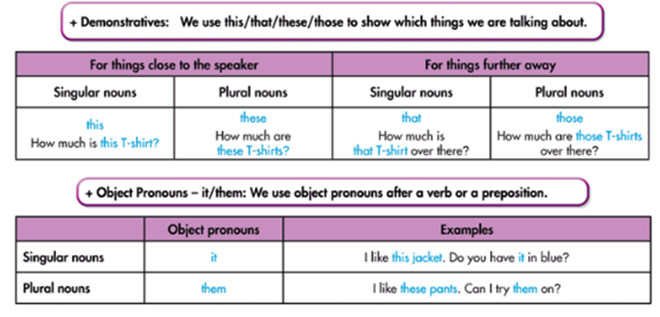

Exercises

I. New Words:

a. Fill in the table.

|  |  |  |
| --- | --- | --- |
| clothes | sizes | others |
|  |  |  |
|  |  |  |
|  |  |  |
|  |  |  |

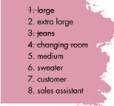

II. Listening. 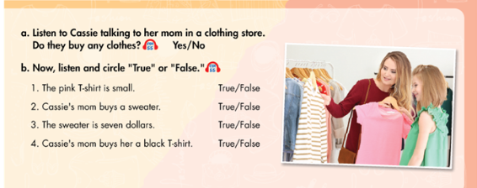

True / False

True / False

True / False

True / False

Yes / No

Listen and fill in the blanks

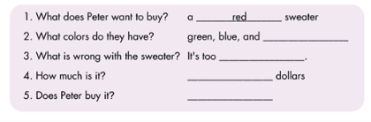

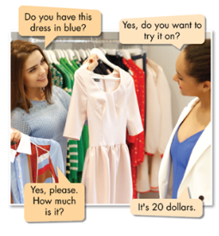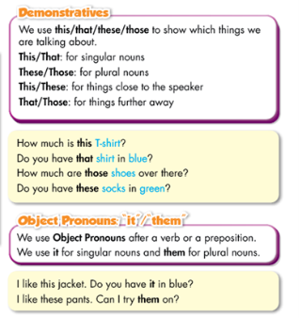III. Grammar

a. Listen and repeat

b. Read the sentences . Circle the correct words.

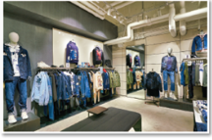1. How much are that / those shoes?

2. Excuse me, how much is this / these shirt?

3. I like that skirt. Do you have it / them in black?

4. Do you have this / these shoes in black?

5. I like these shorts. Can I try it / them on?

6. What size are those / these pants over there?

7. How much is that / this shirt by the window?

c. Complete the dialogue with this, those, it, or them.

